Books for 14-18 year olds

 | Title | RRP | Camp Price | Qty
Little Black Books
Little Black Books are a new series of books that get straight to the point on the topics that Christians always have questions about. Not too big, not too fancy, and not at all boring. LBBs are ideal for young Christians, but speak biblical truths applicable to any age range.
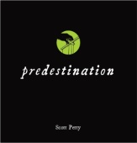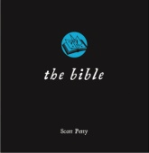  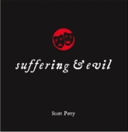 | Little Black Books  Sex, Predestination, The Bible, Suffering & Evil, What's Life all About?, God and Science and The Holy Spirit | £2.99 each | Only £2.30
Books for Young People
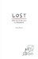 | Lost  A lively and engaging retelling of the Prodigal Son with a powerful application and challenge. | £4 | Only £3
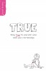 | True  A book to help younger teenage girls be excited about living for Jesus in every relationship in their lives. | £6 | £4
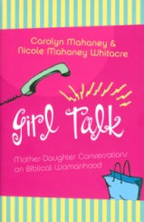 | Girl Talk  Insights and suggestions on how to talk — really talk — to each other about what it means to become a godly woman. | £9 | Only £7
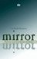 | Mirror Mirror  The world tells us that we need a good self-image. The Bible says that we need a right self-image. | £8 | Only £5
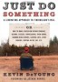 | Just Do Something  Kevin DeYoung counsels Christians to settle down, make choices, and do the hard work of seeing those choices through. | £9 | Only £7
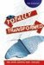 | Totally Transformed  If you are in Christ, you are a new creation. God has totally transformed you! Find out how! | £8 | Only £5
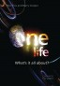 | Christianity Explored  If you are in Christ, you are a new creation. God has totally transformed you! Find out how! | £7 | Only £4
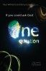 | If You Could Ask God One Question  Answers to the 12 most frequently-asked questions about God. | £ | Only £4
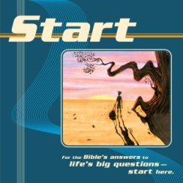 | Start  For the Bible's answers to life's big questions - START here! | £3 | £2.55
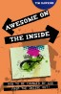 | Awesome on the Inside  Written to help teenagers of the 21st century, explore the Bible to discover the big things that God wants from them. | £7.00 | Only £5
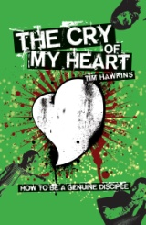 | The Cry of My Heart  Shows you how to be a genuine disciple, by exploring Jesus' very own discipleship manual: The sermon on the Mount. | £7.00 | Only £5
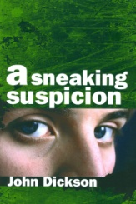 | A Sneaking Suspicion  This is a book about things that matter - things like life, death, relationships, sex, suffering, meaning and God. | £6.99 | Only £5
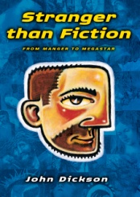 | Stranger than Fiction  More movies than James Bond and over a billion people say he can save the world. That's Stranger Than Fiction | £6.99 | Only £5
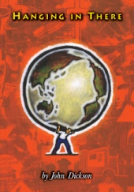 | Hanging in There  If you're new to christianity or a long-serving Christian who could use a bit of encouragement, this book is for you. | £6.99 | Only £5
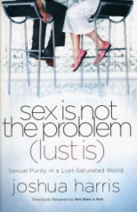 | Sex is not the problem (lust is)  Joshua Harris calls a generation bombarded with images of sexual sin back to the freedom and joy of holiness | £9 | Only £6
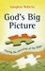 | God's Big Picture  The Bible is clearly no ordinary book. How can we begin to read and understand it as a whole? | £8 | £6.80
 | Idols  The aim of this book is to both diagnose and destroy idols in our lives. | £9 | £6
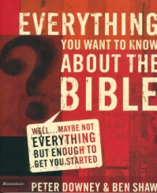 | Everything You Want to Know about the Bible  In short readable chapters, the authors answer some basic questions about the Bible, then take you on a guided tour. | £11 | £8.50
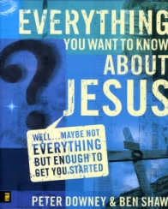 | Everything You Want to know about Jesus  If history has a fulcrum, Jesus is it. Find out who he was and why he came. | £11 | £8.50
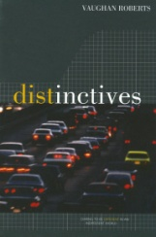 | Distinctives  Vaughan Roberts, issues a challenging call to Christians to live out their faith. | £6 | Only £5
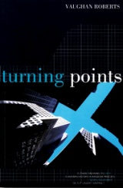 | Turning Points  This book aims to help you see history as God sees it, so that you might fit in with his plans for the world. | £6 | Only £5
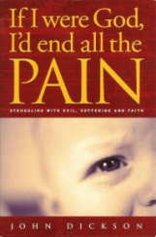 | If I were God - I'd end all the pain  Can we still believe in God in the face of all the suffering and pain in the world? | £5 | £4.25
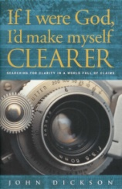 | If I were God - I'd make myself clearer...  With so many religions on offer, can one of them be considered true? | £5 | £4.25
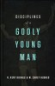 | Disciplines of a godly young man  An adaption of the brilliant Disciplines of a godly man for younger men. | £8.99 | £7
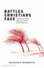 | Battles Christians Face  Equips with practical weapons to fight daily battles. | £7 | £5
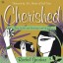 | Cherished  Tackling issues facing teenage girls. | £8 | £5
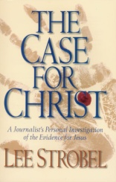 | The Case for Christ  Lee Strobel cross-examines a dozen experts regarding the evidence for Jesus of Nazareth. | £4.00 | £3.40
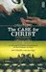 | Case for Faith – Youth Edition  Join Lee Strobel as he retraces his journey from skepticism to faith. | £7.00 | Only £5
Bible Reading Notes
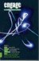 | Engage Issue 1  Daily Bible reading notes for young people | £4 | £1
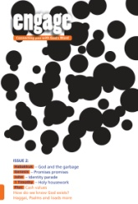 | Engage Issues 2 to 13  Daily Bible reading notes for young people | £4 | £1
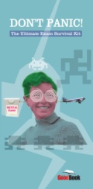 | Don't Panic  An exam survival guide including 20 daily Bible readings for stressed-out students. | £2.50 | £1
Tracts and Booklets
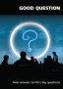 | Good Question  Short tract answering difficult questions. | £1 | 50p
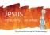 | Jesus. Who, why…so what?  Simple gospel outline using 5 pictures. | 75p each | 50p
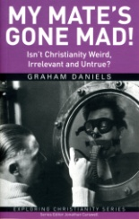 | My Mate's Gone Mad  Graham Daniels tackles some common objections to Jesus and Christianity head on. | £3 | £2.55
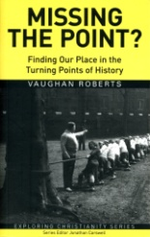 | Missing the Point  Missing the Point looks at the most important turning points of history as outlined in the Bible. | £3 | £2.55
Bibles and Gospels
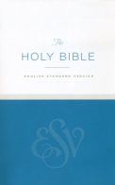 | ESV Economy Bible | £2 | £1.70
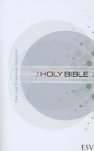 | ESV Outreach Bible | £4 | £3.40
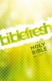 | NIV 11 Biblefresh | £5.00 | Only £4
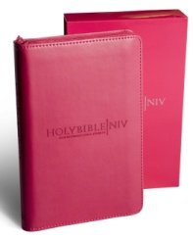 | NIV Pink Compact Zip-up Bible | £16.00 | £13.60
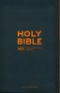 | Slate zip up Bible | £16 | £12
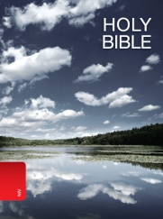 | NIV Popular Bible | £10.00 | Only £7.50
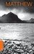  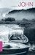 | NIV Gospels | £1.00 each | £1 or  10 for £5
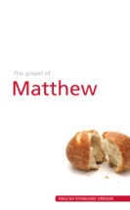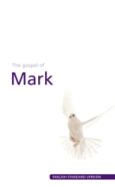  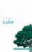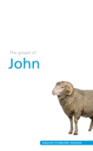 | ESV Gospels | £1.00 each | £1 or  10 for £5

THE GOOD BOOK COMPANY
CAMPSTALL IN A BOX
ORDER FORM
DELIVERY DETAILS (if different):

Contact Name:

Address:

ACCOUNT DETAILS:

Name:

Address:

Telephone: Email:

I would like to order the books marked on the attached order form.

I agree to the terms and conditions set out on the attached sheet.

Signed:

Date:

Please return this form to
The Good Book Company, Blenheim House, 1 Blenheim Rd, Epsom, KT19 9AP

