Books for 10-14 year olds

 | Title | RRP | Camp Price | Qty
Little Black Books
Little Black Books are a new series of books that get straight to the point on the topics that Christians always have questions about. Not too big, not too fancy, and not at all boring. LBBs are ideal for young Christians, but speak biblical truths applicable to any age range.
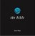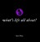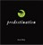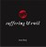 | Little Black Books  Sex, Predestination, The Bible, Suffering & Evil, What's Life all About?, The Holy Spirit and Science and God | £2.99 each | Only £2.30
Books for Young People
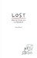 | Lost  A lively and engaging retelling of the Prodigal Son with a powerful application and challenge. | £4.00 | Only £3
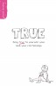 | True | £6 | £4
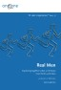 | One2oOne Real Men | £4 | £3
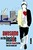 | Awesome on the Inside  Written to help teenagers of the 21st century, explore the Bible to discover the big things that God wants from them. | £7.00 | Only £5
 | The Cry of My Heart  Shows you how to be a genuine disciple, by exploring Jesus' very own discipleship manual: The sermon on the Mount. | £7.00 | Only £5
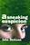 | A Sneaking Suspicion  This is a book about things that matter - things like life, death, relationships, sex, suffering, meaning and God. | £6.99 | Only £5
 | Stranger than Fiction  More movies than James Bond and over a billion people say he can save the world. That's Stranger Than Fiction | £6.99 | Only £5
 | Hanging in There  If you're new to christianity or a long-serving Christian who could use a bit of encouragement, this book is for you. | £6.99 | Only £5
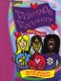 | Forever Friends | £5 | £4
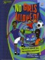 | No Girls Allowed | £5 | £4
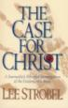 | The Case for Christ  Lee Strobel cross-examines a dozen experts regarding the evidence for Jesus of Nazareth. | £4.00 | £3.40
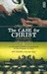 | Case for Faith – Youth Edition  Join Lee Strobel as he retraces his journey from skepticism to faith. | £7.00 | Only £5
LightKeeper Series
Each book has 10 short biographies of Inspirational lives which will serve as an example - It includes fact files, prayer suggestions and quizzes.
 | Ten Girls Who Made a Difference | £6.00 | Only £4.80
 | Ten Boys Who changed the World | £6.00 | Only £4.80
 | Ten Boys Who Used Their Talents  What can you do for God? | £6.00 | Only £4.80
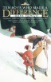 | Ten Boys who made a difference | £6 | £4.80
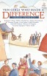 | Ten Girls who made a difference | £6 | £4.80
 | Ten Girls Who Used Their Talents – What can you do for God?  Irene Howat | £6.00 | Only £4.80
Trailblazer Series
This series is aimed at 9-14 year olds and retells the stories of well-known Christians past and present.
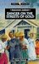 | Danger on the Streets of Gold  Adoniram Judson | £6 | Only £4.80
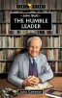 | The Humble Leader  John Stott | £6 | £4.80
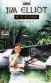 | He is no fool | £6 | £4.80
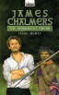 | The Rainmaker's Friend | £6 | £4.80
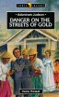 | Danger on the streets of gold | £6 | £4.80
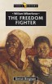 | The Freedom Fighter  William Wilberforce | £6 | £4.80
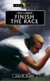 | Finish the Race  Eric Liddell | £6 | £4.80
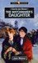 | The Watchmaker’s Daughter  Corrie Ten Boom | £6 | Only £4.80
Torch Bearer Series
The style of the series is fictional but each book focuses on a real martyr from history
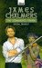 | The Rainmaker’s Friend  James Chalmers | £6.00 | Only £4.80
 | He is No Fool  Jim Elliot | £6.00 | Only £4.80
Bible Reading Notes
 | Discover 59  Three months of Bible reading notes | £3.25 | £2
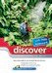 | Discover Starter Pack 1  Three weeks of Bible reading notes  (Mark and Psalms) | £1.50 | £1
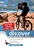 | Discover Starter Pack 2  Three weeks of Bible reading notes  (Mark and How to Pray) | £1.50 | £1
 | Discover Starter Pack 3  Three weeks of Bible reading notes  (Luke and How to become a Christian) | £1.50 | £1
Tracts and Booklets
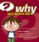 | Why Did Jesus Die?  Children’s tract explaining Jesus’ death | 25p each
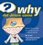 | Why Did Jesus Come?  Children's tract explaining Jesus' purpose | 25p each
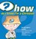 | How do I know I’m a Christian?  Evangelistic tract for children and young people | 25p each
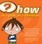 | How do I grow as a Christian?  Tract encouraging spiritual growth | 25p each
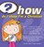 | How do I show I’m a Christian?  Helps young people share their faith | 25p each
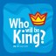 | Who will be King? | 75p | 50p
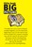 | Little Book: Big Picture  Mini Bible overview | 20p each
 | What’s it all about?  An evangelistic booklet for teenagers who need to know what Christianity is all about. | 25p each
 | Sorted Tract  An evangelistic youth tract ideal for teens aged 13-19 | 10p each
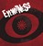 | Eyewitness Tract  A short tract for young people written to encourage them to realise that the cross and resurrection are real events | 25p each
Bibles and Gospels
 | ESV Economy Bible | £2 | £1.70
 | ESV Outreach Bible | £4 | £3.40
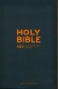 | Slate zip up Bible | £16 | £12
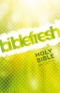 | Biblefresh Paperback | £5.00 | Only £4
 | NIV Pink Compact Zip-up Bible | £16.00 | £13.60
 | NIV Popular Bible | £10.00 | Only £7.50
  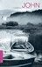 | NIV Gospels | £1.00 each | £1 or  10 for £5
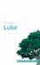 | ESV Gospels | £1.00 each | £1 or  10 for £5

THE GOOD BOOK COMPANY
CAMPSTALL IN A BOX
ORDER FORM
DELIVERY DETAILS (if different):

Contact Name:

Address:

ACCOUNT DETAILS:

Name:

Address:

Telephone: Email:

I would like to order the books marked on the attached order form.

I agree to the terms and conditions set out on the attached sheet.

Signed:

Date:

Please return this form to
The Good Book Company, Blenheim House, 1 Blenheim Rd, Epsom, KT19 9AP

